ORA daļai atbilstošas ATO pieteikuma apstiprināšanas vadlīnijas
Application for a Part – ORA ATO Approval User Guide

Valodas lietošana / Language Used

Šā dokumenta "User Guide" specifisku saturu ir noteikusi Eiropas Drošības aģentūra (EASA) un tāpēc tas ir prezentēts tikai angļu valodā, bez tulkojuma. Ja dokumenta lietotājs sastopas ar jebkādām tulkošanas grūtībām, Valsts aģentūras “Civilās aviācijas aģentūra” Mācību un eksaminēšanas nodaļā viņš var saņemt nepieciešamo palīdzību lai noskaidrotu radušos jautājumus.

This essence of this "User Guide" originates from EASA and as such has been prepared in the English Language. Should users of this guide encounter difficulties in the language used, they are invited to contact CAA of Latvia (LVCAA) Training and Examinations Department for translation assistance.

Table of Contents
Chapter 1 - Initial approval 5
1.1. Application to LVCAA for an ATO Part ORA approval 5
1.2. Allocation of the team 5
1.3. Initial technical investigation 5
1.3.1. Documents and compliance declaration 5
1.3.2. Preparation of the investigation 6
1.3.3. On site investigation 6
1.3.4. Recommendation 7
1.3.5. Issuance of an approval Certificate 7
1.4. Time frame 7
Chapter 2 - Change of approval 9
2.1. Application for change 9
2.2. Allocation of the team 9
2.3. Technical Investigation for Change 9
Chapter 3 - Continued surveillance 10
Chapter 4 - Transition from JAR FCL 12
4.1. The “grandfathering” concept 12
4.2. Adapting to the new regulation 12
4.3. Requirements and terms of approval 13
4.4. Initiation of the grandfathering oversight cycle 13
4.5. On site investigation 14
4.6. Management of findings 14
4.7. Recommendation 16
4.8. Changes to approval under grandfathering 16
Chapter 6 - Correspondence and focal points 17

Chapter 1 - Initial approval

Application to LVCAA for an ATO Part ORA approval
A new application for an LVCAA pilot Training Organisation Approval shall be made in accordance with ORA.ATO.105 using the form “Application for a Part–ORA ATO Approval” (Appendix 1 to this User Guide). This Application form shall be sent directly to LVCAA secretary (for registration), in person, or by surface mail, in accordance with the instructions contained on the application form.
Details about the Regulations can be obtained directly from the CAA of Latvia Training and Examinations Department.
LVCAA Training and Examinations Department will acknowledge receipt of the application by email to the email address indicated in the application form.
LVCAA Training and Examinations Department will check the application. When incorrect or incomplete information is supplied, the applicant shall be notified as soon as possible detailing the omissions and errors. If significant omissions, errors or failure to comply with Application form instructions are identified, the application shall be rejected in its entirety by the LVCAA Training and Examinations Department, which will always be communicated to the ATO by written letter, the complete application package shall then be available for collection from the LVCAA by prior appointment.
Initial application package must include The Form “Application for a Part–ORA ATO Approval” (Appendix 1 to this User Guide) completed in accordance with the instructions given therein, and supported by all relevant supporting documents mentioned therein.
In case of refusal of an application, LVCAA Training and Examinations Department will notify this decision in writing to the applicant together with the reasons thereto.
Once the application package is complete, the LVCAA Training and Examinations Department checks the eligibility of the application according to applicable regulation. This will include an in-depth review of supporting documentation and the application form supplied.
When eligibility has been fully assessed the applicant is informed by LVCAA Training and Examinations Department of the preliminary approval number with a suffix “P” indicating the pending status of the approval (for example LVA.ATO.XXP).

Allocation of the team
When eligibility for approval has been confirmed an inspector from the LVCAA Training and Examinations Department will be allocated to initial and continuing oversight of the ATO.
The allocated inspector will establish an appropriate LVCAA certification team using LVCAA staff, and external specialists where such specialists may be advisable (e.g. inspectors from another Authority).

Initial technical investigation

Documents and compliance declaration
Upon receipt of the LVCAA allocation decision, the allocated inspector shall receive organisations’ documents and manuals, lists of staff and key personnel and any other details as required by Part ORA. The “LVCAA - User guide for ATO Manuals” should be used as much as possible to ease this step.
While the technical investigation team is reviewing the documents and information provided, an internal audit of the entire training organisation shall be performed through the applicant’s internal compliance monitoring system (indicated in “Application for a Part–ORA ATO Approval” Form (Appendix 1) to ascertain compliance with all applicable requirements related to the requested scope of the approval.
When the internal compliance audit has been completed and all the findings and issues addressed, a statement of compliance signed by the Organisation’s Accountable Manager (OAM) shall always be provided before the LVCAA allocated inspector’s technical investigation takes place, confirming that the documents, procedures, facilities, equipment and personnel subject to the application have been reviewed and audited and that all findings have been properly addressed so that the whole internal audit process demonstrates full compliance with all applicable requirements.
A scanned copy of this compliance audit report along with scanned copies of all supporting evidence shall be provided by the Applicant by email to the Head of Training and Examinations Department:
caa@caa.gov.lv
If at this stage non-conformities are detected, these shall be notified by email.

Preparation of the investigation
When all of the
- documents and forms,
- Organisation’s Accountable Manager statement, and
- compliance audit report
are deemed acceptable, the allocated inspector will initiate the investigation in accordance with applicable regulation, associated Acceptable Means of Compliance (AMC) / Guidance Material (GM).
In particular the allocated inspector will:
- Coordinate with the Organisation for scheduling the audit and
- Prepare and notify the Organisation with the audit plan.

On site investigation
During this phase, the allocated inspector will:
- Start the investigation audit with an opening meeting with the ATO management and where possible with the Accountable Manager at least to:
  - Present the audit scope
  - Confirm the audit schedule
  - Outline the Purpose, Process, Standards & Methods related to the audit and the finding reporting
  - Confirm the planning of the closing meeting
- Meet the Accountable Manager during the visit
- Conduct a closing meeting to present the audit findings and conclusions to the ATO management in order to ensure that they are understood. The ATO management will be given the opportunity to discuss any non-compliance identified and suggest corrective actions and a timeframe for implementation.
Findings identified during the investigation process will be handled by the allocated inspector according applicable regulation, associated Acceptable Means of Compliance (AMC) / Guidance Material (GM) and Internal LVCAA Training and Examinations Department procedures and work instructions.
For an initial Part-ORA approval, all findings raised during the initial audit shall be tracked and closed within 3 months before the recommendation is made. Failure to close these findings during this timeframe could lead the LVCAA to terminate the application in a similar manner to that described in Chapter 1.1.
The formal notification of the findings will be prepared in hard copy for the Organisation by the allocated inspector within a maximum of 15 calendar days from the end of the audit. A management representative with signatory rights (preferably the Compliance Monitoring Manager) is required to collect these from the LVCAA Training and Examinations Department, in person, following notification of their preparation which shall be communicated by the allocated inspector to the organisation by email. Upon collection of the formal notification of findings, the Organisation’s representative will be required to sign in receipt of the hard copies.
Following receipt of finding notifications, the Organisation is obliged to provide the allocated inspector with:
- A root cause analysis
- Corrective action plan
And subsequently
- Statement of implementation of finding corrective actions (hard copy only)
While no specific timeline is attached to the presentation of the above analysis and plan (within the 3 month finding clearance period), it is in the interest of the organisation to complete these and provide them to the LVCAA as early as possible in the finding clearance process, not least because effectiveness of the compliance monitoring system of the organisation (including root cause analysis and preparation of corrective action plans) is an essential requirement and audited function of the approval process – delays in presenting these will be considered to be an indication of lack of preparation of the organisation to receive a Part-ORA certificate.
When the Organisation considers all findings to be closed, a notification of finding closure must be formally submitted to the allocated inspector. This may be done in person and is entered onto the same form as the finding notification.
The allocated inspector will follow-up the closure of all findings identified during the audit, which may include a follow-up audit specifically for this purpose. When he/she is satisfied that the corrective actions taken by the Organisation have properly addressed the finding raised during the audit, he/she will provide the original finding clearance notifications to the LVCAA Head of Personnel Licensing Division along with a recommendation to close the findings. Subsequently the allocated inspector shall notify the Organisation in writing that the non-compliances are considered to be closed, which shall be notified by telephone or email and formally communicated on the finding notification form.
Depending on the extent and nature of findings and the related corrective actions to be implemented, an additional full audit may be necessary.
The whole initial approval process leading to the issuance of the recommendation shall typically be completed within a 7 months after receipt of the allocation decision when the organisation is informed by the Agency about the allocated inspector.

Recommendation
When compliance of the applicant with Part-ORA requirements has been established, the allocated inspector will submit a recommendation package to LVCAA Head of Personnel Licensing Division recommending the issuance of an ATO certificate.

Issuance of an approval Certificate
When satisfied that the recommendation package is accurate and compliant with relevant procedures and requirements the LVCAA Training and Examinations Department will prepare the relevant approval certificate Form 143 for signature by LVCAA Head of Personnel Licensing Division.
LVCAA Training and Examinations Department will make the original signed EASA Form 143 available for collection. Collection of the EASA form 143 shall also be linked to the payment of certification fees as they fall due.

Time frame
The normal time frame to process a Part-ATO approval is about 7 months from the allocation date; however the amount of time taken is largely dependent on the ability of the applicant to produce the documentation required and to rectify any non-conformity identified during the certification process. Unless duly justified, failure to meet this 7 month time frame might lead the LVCAA to terminate the application in the manner described in Chapter 1.1 of this User Guide.

Simplified time frame for an Initial ATO Approval
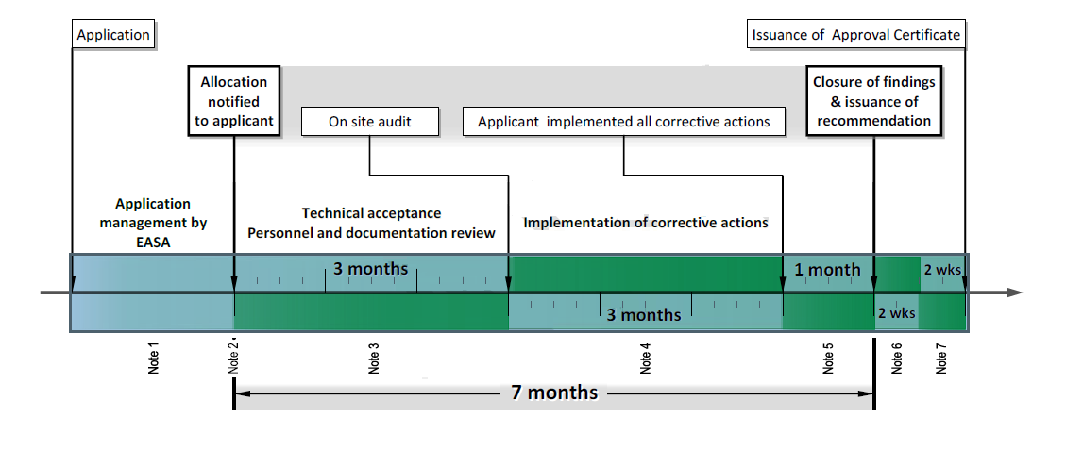
CAA
Note 1: To inform applicant about any omission or error if incorrect or incomplete information supplied
Note 2: The applicant is informed by LVCAA about the designated allocated inspector who shall be the custodian of the Organisation’s manuals and will act as LVCAA focal point.
Note 3: Allocated inspector to review organisation’s manuals, applicant to implement correction up to an acceptable level following internal audit.
Note 4: Applicant to implement of corrective actions and notify allocated inspector accordingly
Note 5: Head of PLD to close findings upon recommendation and recommendation package issued by allocated inspector
Note 6: Quality check of ATO Recommendation Form and validation of recommendation package
Note 7: LVCAA to process the recommendation package and issue the Approval Certificate EASA Form 143

Chapter 2 - Change of approval

Application for change
All changes as detailed in ORA.GEN.130 (a) & (b) require completion of a Form “Application for a Part–ORA ATO Approval” (Appendix 1). An application for the change of an LVCAA Part-ORA Approval shall be made in accordance with ORA.ATO.105 (c). This Application form shall be sent directly to LVCAA in person or by surface mail, with an email being sent to the Head of Training and Examinations Department:
caa@caa.gov.lv
Details about the Regulations can be obtained directly from the CAA of Latvia Training and Examinations Department.
LVCAA Training and Examinations Department will acknowledge receipt of the application by email to the email address listed on the original application form (or the revised one where it gives a different email address).
LVCAA Training and Examinations Department will check the application. When incorrect or incomplete information is supplied, the applicant shall be notified as soon as possible by letter or email detailing the omissions and errors. If significant omissions, errors or failure to comply with Application form instructions are identified, the application shall be rejected in its entirety by the LVCAA Training and Examinations Department, which will always be communicated to the ATO by written letter, the complete application package shall then be available for collection from the LVCAA by prior appointment.
Application for a change of Approval name must include the Organisations’ Legal Status Document (Certificate of Incorporation [for profit organisations] or an equivalent official document [for non-profit organisations]) as detailed in the Form “Application for a Part–ORA ATO Approval” (Appendix 1).
In case of refusal of an application, LVCAA Training and Examinations Department will notify this decision in writing to the applicant together with the reasons thereto.
Once the application package is complete, the LVCAA Training and Examinations Department checks the eligibility of the application according to applicable regulation.
When eligibility has been fully assessed, the allocated Training and Examinations Department inspector shall processed with handling the application.
The applicant shall have included all documents related to the change as attachments to the application.

Allocation of the team
By default the investigation is performed by the assigned initial team. However, should it become necessary or more appropriate to allocate a different inspector, the LVCAA Head of Training and Examinations Department makes the decision to allocate another LVCAA inspector.

Technical Investigation for Change
To process a change the allocated inspector will precede as detailed within the paragraphs related to “Initial technical investigation”.
The ATO cannot implement changes prior to LVCAA formal approval.

Chapter 3 - Continued surveillance
An Oversight Planning Cycle will normally be prepared by the allocated inspector parts of which may be made available to the ATO upon request. This will typically be performed on an bi-annual basis, reviewed at least annually and is subject to approval of the Head of Training and Examinations Department.
By default the frequency of auditing is one inspection per year.
This default frequency will be adjusted according to a risk based evaluation depending on criteria such as:
- Organisation’s capacity to demonstrate an effective identification of aviation safety hazards and management of associated risks
- Organisation’s capacity to continuously demonstrate under ORA.GEN.130 that it has full control over all changes
- Relevance of previous audit findings
- Reactivity to findings and effectiveness of corrective action implementation
- Frequency of repetitive findings
- Effectiveness of compliance monitoring
- Volume and range of activity of the organisation
- Size, complexity and culture of the organisation (Number of staff, number of aircraft, structure, strategy, technology, environment, safety culture, reporting culture, discipline measures, level and intricacy of outsourcing, location fragmentation …)
- Capacity to implement effective continuous reporting system to LVCAA on the safety performance and regulatory compliance of the organisation itself
- Other criteria as might be necessary to comply with relevant requirements (such as but not limited to ARA.GEN.305(b)), to comply with regulation related to aviation safety or to apply international aviation safety standards.
Every 24 months the allocated inspector will review the outcome of the surveillance activity related to the ATO to confirm whether or not the organisation continues to satisfactorily comply with the relevant requirements and applicable standards. This will be formally stated in a recommendation submitted to the Head of Personnel Licensing Division.
At the time of the continuation, recent pending findings within the accepted corrective action implementation period may be still open. However it should be clearly stated that, at the time of the recommendation, all open findings shall fulfil the requirements of ORA.GEN.150 (a) & (b) so that the related:
- root cause of each finding is identified
- corrective action plan is submitted and accepted by the allocated inspector in charge of the recommendation;
The allocated inspector will issue a recommendation only if each previous finding which is still open falls under the provisions of ORA.GEN.150 (c) within the period agreed.
When the allocated inspector has finished the preparation of the recommendation package this package is reviewed for quality check by Head of Personnel Licensing Division
When continued validity of the certificate is accepted the allocated inspector shall notify the ATO by email.
Findings raised during the continued surveillance will be handled by the allocated inspector according to ARA.GEN.350 and its AMC / GM.
By default the continued surveillance is performed by the assigned initial team. However, should it become necessary or more appropriate to allocate a different auditor, the Head of Personnel licensing Division will decide about a different inspector and assign another LVCAA allocated inspector. In this case, the Head of Personnel Licensing Division will inform the LVCAA Training and Examinations Department who will inform the selected allocated inspector together with the applicant by email.

Simplified Time frame for continuation of ATO Approval
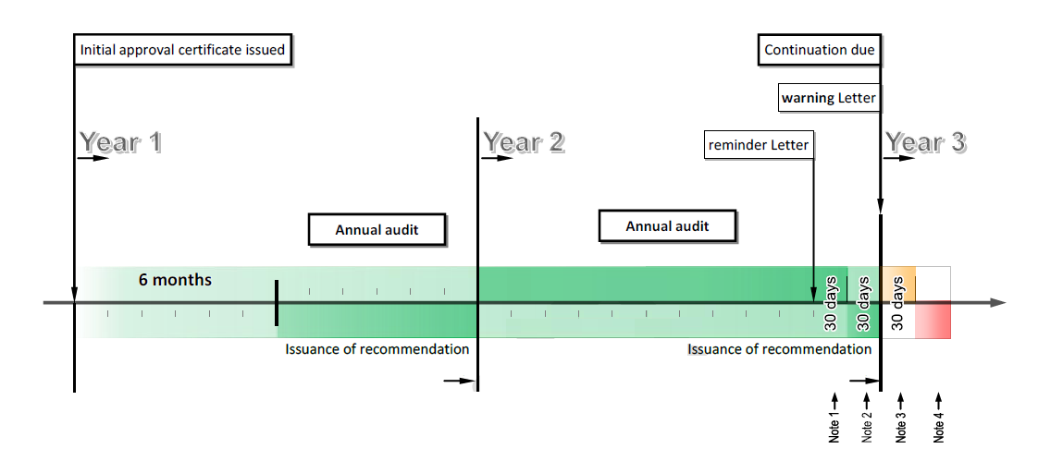
Note 1: LVCAA to send a reminder email 60 days before continuation due date
Note 2: Recommendation package not to be dated more than 30 days BEFORE continuation due date.
Note 3: Recommendation package not to be dated more than 30 days AFTER continuation due date.
Note 4: In case of a documented extension request is to be sent to LVCAA before the end of the month following the continuation due date.

Chapter 4 - Transition from JAR FCL

The “grandfathering” concept
Article 10a (2) of Aircrew regulation states that: Pilot training organisations holding JAR-compliant certificates issued or recognised by a Member State before this Regulation applies shall be deemed to hold a certificate issued in accordance with this Regulation1.
In such case the privileges of these organisations shall be limited to the privileges included in the approval issued by the Member State.
Without prejudice to Article 2, pilot training organisations shall adapt their management system, training programmes, procedures and manuals to be compliant with Annex VII by 8 April 2014 at the latest.
Items (13) of article 2 of Aircrew regulation, clarifies the meaning of “JAR-compliant certificate, approval or organisation”: ‘JAR-compliant certificate, approval or organisation’ means the certificate or approval issued or recognised or the organisation certified, approved, registered or recognised, in accordance with the national legislation reflecting JAR and procedures, by a Member State having implemented the relevant JAR and having been recommended for mutual recognition within the Joint Aviation Authorities' system in relation to such JAR."
“Grandfathering”, in the present guide, means the recognition under Article 10a (2) of Aircrew regulation, of a pilot training organisation (PTO) holding a JAR-compliant certificate as a Part ORA Approved Training Organisation (ATO).
This means that:
a. The PTO will be considered as a Part ORA ATO by recognition of the JAR-FCL compliant Approval according to Article 10a (2) of Aircrew regulation
b. The privileges of the Part ORA ATO credited under Article 10a (2) of Aircrew regulation are limited to the equivalent Part FCL privileges matching the related privileges of the JAR FCL Approval Certificate.
c. The training organisation complies with Article 10a (2) of Aircrew regulation by adapting its management system, training programmes, procedures and manuals to be compliant Part ORA by 8 April 2014 at the latest and having undergone a complete application process in accordance with the application procedures contained herein including being subject to an Authority audit of compliance with Part ORA.
It should be noted that the introduction of any new courses would require the ATO to be fully compliant with the provisions of Part ORA and that “Grandfathering” is applicable only to courses approved before 8 April 2013.

Adapting to the new regulation
As explained above, a “Grandfathered ” ATO is required to adapt its management system, training programmes, procedures and manuals to be compliant with Part ORA by 8 April 2014 at the latest (Article 10a (2) of Aircrew regulation).
This means that the grandfathered ATO shall adapt its management system, training programmes, procedures or manuals before reaching the deadline of 8 April 2014, and these shall have passed an Authority audit (with all findings cleared) by that date.
These changes have been considered by the regulation significant enough to require up to two years of transition. As a consequence all changes shall be submitted to the CAA of Latvia for approval “before any such change takes place, in order to enable the competent authority (the CAA of Latvia in this case) to determine continued compliance with Regulation (EC) No 216/2008 and its Implementing Rules and to amend, if necessary, the organisation certificate and related terms of approval attached to it” as required by ORA.GEN.130 (b). This will enable the CAA of Latvia to develop an oversight programme based on the assessment of the risks related to the planned changes taking into account the specific nature of the organisation, the complexity of its activities, the results of past certification and/or oversight activities as required by ARA.GEN.305 (b)
The changes needed to ensure initial and continued compliance with Article 10a (2) of Aircrew regulation by adapting the organisation’s management system, training programmes, procedures and manuals to be compliant with Part ORA by 8 April 2014 at the latest as explained above, will be managed in two steps:
a. At the initiation of the grandfathering oversight cycle For the preparation of the first audit, the grandfathered ATO shall provide evidence that the organisation has planned the implementation of Article 10a (2) of Aircrew regulation by indicating how the ATO intends to adapt its management system, training programmes, procedures and manuals to be compliant with Part ORA by 8 April 2014 at the latest.
b. During the transition phase between April 2012 and April 2014 The grandfathered ATO shall demonstrate that the implementation plan adopted as indicated in the previous step is being carried out, monitored, adjusted and satisfactorily managed so as to achieve effective compliance by the deadline set in Article 10a (2) of Aircrew regulation. It shall also be required to demonstrate continued compliance with the requirements of the existing approval (JAR-FCL), up to the point of Part ORA certificate issue
Failure to provide an implementation plan of Article 10a (2) of Aircrew regulation or to commit the resources needed or to satisfactorily manage the project to achieve the plan will be considered as a non-compliance with regards to Article 10a (2) of Aircrew regulation.

Requirements and terms of approval
All Part ORA requirements are applicable to the grandfathered ATO with the exceptions stated in Article 10a (2) of Aircrew regulation. This means that Part ORA requirements related to:
- The management system;
- The training programmes;
- The procedures and
- The manuals are NOT applicable before:
  - the planned date of implementation provided by the organisation as indicated in 4.2.a above or
  - 8 April 2014 at the latest
In the meantime the JAR FCL requirements will be considered as part of the terms of approval under Article 10a (2) of Aircrew regulation attached to the Part ORA certificate delivered by LVCAA.
As a consequence, where Part ORA requirements are not applicable under Article 10a (2) of Aircrew regulation, the grandfathered training organisation shall apply JAR FCL requirements as part of the terms of approval: hereafter referred as JAR TM/AP OR.

Initiation of the grandfathering oversight cycle
As a general rule the initiation of the grandfathering oversight cycle shall follow the process described in Chapter 1.
In all cases, to initiate the grandfathering oversight cycle under Article 10a (2) of Aircrew Regulation, the ATO shall provide a documented implementation plan of the adaptation of its management system, training programmes, procedures and manuals to achieve compliance with Annex VII by 8 April 2014 as indicated in 5.2.a above.
There is no need to conduct a specific compliance audit as required in 1.3.1 above, however a statement of compliance signed by the Organisation’s Accountable Manager (OAM) shall always be provided before the first LVCAA Training and Examinations Department technical investigation takes place to confirm that the documents, procedures, facilities, equipment and personnel subject to the application are fully compliant with:
- all Part ORA requirements related to its continuation under Article 10a (2) of Aircrew Regulation.
The allocated inspector will prepare the investigation based on the implementation plan provided by the organisation (see 5.2.a above) and all the documents made available for the continuation of approval under grandfathering.
The first technical investigation of a grandfathered JAR FCL ATO will be considered as an investigation for continuation of approval. This means that the assessment shall be conducted as it would be for an ATO already approved under Part ORA except that the applicable standards and requirements to be considered as explained in 5.3 above.
Initially, the allocated inspector shall review the implementation plan provided by the ATO (see 5.2.a above) describing how the organisation intends to comply with Article 10a (2) of Aircrew regulation as regards the requirement to adapt its management system, training programmes, procedures and manuals to fully comply with Annex VII by 8 April 2014 at the latest.
The reasonableness of the plan adopted will be assessed based on its feasibility. In particular, this plan shall be sufficiently documented to demonstrate:
a. Correct identification and understanding of the requirements that the organisation’s management system, training programmes, procedures and manuals have to be adapted to.
b. Relevance of the planned actions to be performed to fill the gap between present situation and full compliance with Annex VII by 8 April 2014 at the latest.
c. Adequate capacity of the organisation to bear the financial impact of the plan (How the organisation has determined the funding needs related to the project and when these needs will be faced? How potential extra costs resulting from possible contingencies have been taken into consideration? What financial resources are (or will be) available when needed to ensure the implementation of the plan? …)
d. Acceptable assessment of the technical expertise needed to achieve the plan and description of the contribution of internal / external resources to address these needs.
e. Consistent management of gradual changes throughout the planned steps towards the final objective. (Who will be doing what? How, where and when to proceed? Are the intermediate objectives consistent with the final target? Have the deliverables and criteria of performance for each step been identified and clearly stated? What makes the timing and sequencing of actions workable and sound? How is overall leadership ensured throughout the whole process? …)
f. Acceptable contingency planning (Have the risks of a negative impact on project been identified and taken into consideration? What about personnel: lack of competence, skills or expertise? What about scheduling: in case of late start, accumulated delays? What about cost: underestimated costs, lack of funds? What about priorities: side effect of increased workload in the core business such as providing courses for more trainees, increased needs for new courses to be provided? …)
g. Acceptable identification of key responsibilities and roles of involved personnel and managers.
h. Sufficient commitment. (Who will conduct the project? Is there a clearly identified project manager? What if problems are faced? Who is really going to decide? Has the decision maker sufficient control on the resources needed to face the situation?)
The implementation and effectiveness of the plan shall be evaluated during routine LVCAA inspections of JAR-FCL FTO/TRTO approval certificate holders during the planned oversight cycle for the calendar year 2013/4 until 8 April 2014 after which all ATOs shall have to demonstrate full compliance with Regulation (EU) 216.2008 and its implementing rules.

On site investigation
The process described in 1.3.3 above will generally be followed with the following exceptions:
Level “1” findings will be handled according to the process described in 6 below.
There will be no 7 month time frame.

Management of findings
As a general rule the allocated inspector will manage the findings in compliance with the provisions of regulation (EC) No 216/2008 and its implementing rules and particularly the Aircrew regulation.
Part ORA requirements related to the organisation’s management system, training programmes, procedures and manuals, the associated findings shall be identified in a way that reflects the transition under Article 10a (2) of Aircrew regulation.
The finding shall be determined as illustrated in the following flowchart:

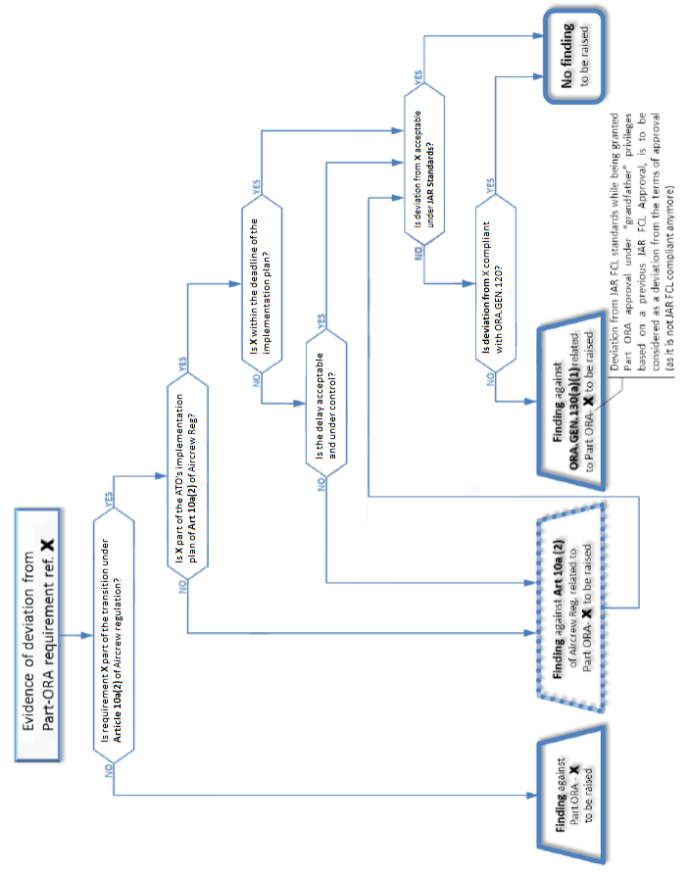

Recommendation
The process described in 1.3.4 above will be followed with the exceptions related to the applicable requirements and terms of approval indicated in 4.3 above.

Changes to approval under grandfathering
As explained under paragraph (c) in 4.1 above, Article 10a (2) of Aircrew regulation restricts grandfathering to the privileges included in the ATO’s JAR FCL approval. As a consequence any change to the scope of the JAR FCL approval can only be accepted if such change is fully compliant with Part ORA and managed by a system as required by ORA.GEN.200 in accordance with Regulation (EC) No 216/2008 and its Implementing Rules. To this end, all LVCAA approved JAR compliant FTO/TRTOs have committed to demonstrating full compliance with the requirements of Regulation (EU) 216/2008 and its implementing rules by 8 April 2014 at the latest.
This is consistent with Article 10a (2) of Aircrew regulation: a grandfathered pilot training organisation shall concentrate its efforts on adapting its management system to the new regulation before 2014 while being granted continuation of business under previously recognized privileges. The transition period between 8 April 2012 and 8 April 2014, should not be wasted in expanding the scope of the approval before achieving the changes required by Article 10a (2) of Aircrew regulation.

Chapter 6 - Correspondence and focal points
The “contact point notification” letter sent by LVCAA specifies the contact details of the recommending entity in charge of the technical investigation and recommendation (ATO Recommendation Form). For any technical issue related to the approval the ATO shall contact the designated allocated inspector.
For any administrative issue such as those related to fees and charges, invoices, the ATO shall directly contact LVCAA Application and Procurement department.
Any application for approval change will also have to be sent to LVCAA. The allocated inspector could be copied in of the Form “Application for a Part–ORA ATO Approval” (Appendix 1) by the ATO.
LVCAA will directly send the formal approval and related documents such as EASA Certificate Form 143 and continuation letter to the applicant.
An audit report could be produced at the time of completion of the audit. But in any case the formal notification of the findings must be sent by the allocated inspector to the Organisation within a maximum of 15 calendar days from the end of the audit.
In case of potential Level “1” finding the allocated inspector will liaise with LVCAA for confirmation of finding level.
When the finding is confirmed as Level “1” non-compliance, the allocated inspector will NOT transmit the audit report to the Organisation. However he/she will transmit a recommendation (ATO Recommendation Form) to the LVCAA Head of Personnel Licensing Division. In this case, LVCAA will notify the finding(s) to the Organisation together with the decision against the approval.

